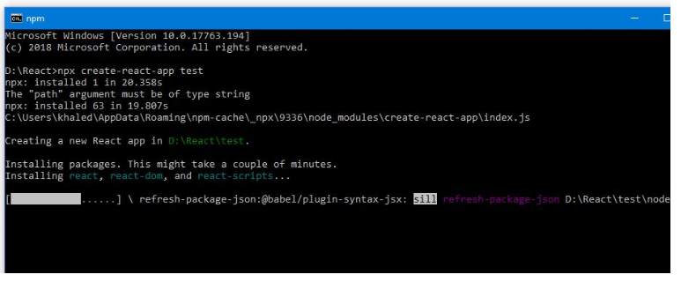

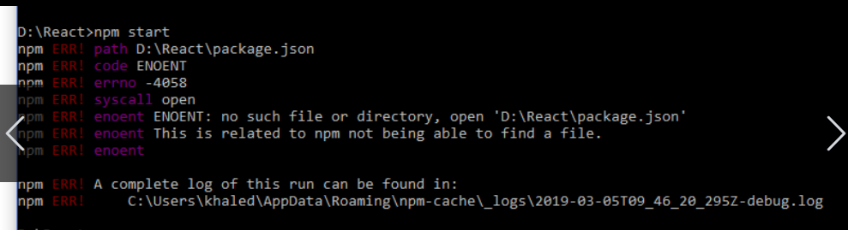

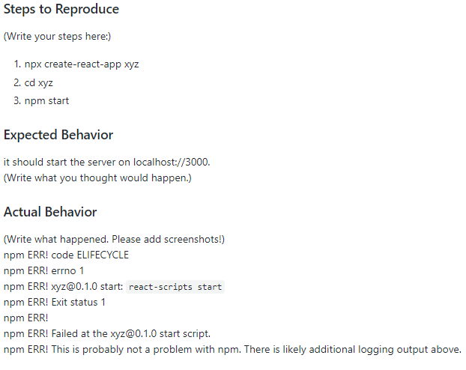

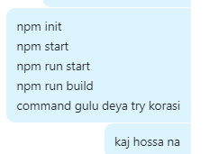

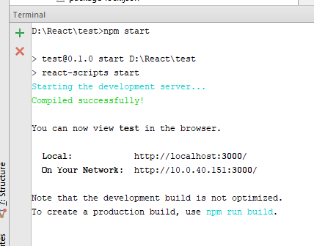

Cd deya Project e jower por

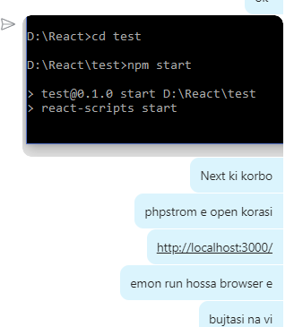

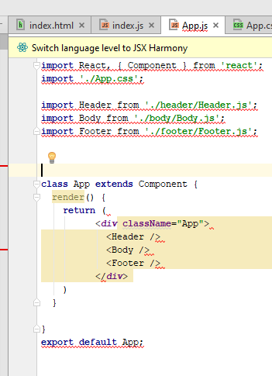

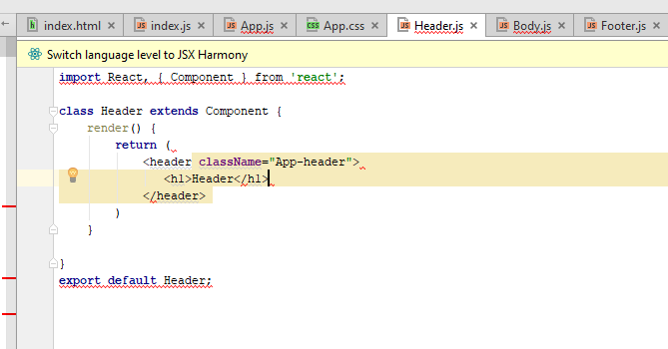

React Router er jonno kono package install deta hoy?

Like:

npm install --save react-router-dom

??

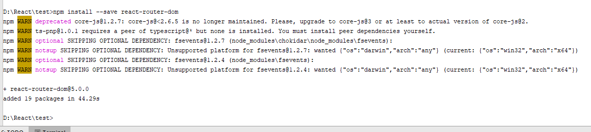

-------------------------------package install--------------------------------------------------------

<https://github.com/sultan0/reactpin>

<https://www.youtube.com/watch?v=YakGxvVYpjw>

<https://reacttraining.com/react-router/web/example/basic>

<https://www.w3schools.com/react/react_props.asp>

<https://react-bootstrap.github.io/getting-started/introduction>

========================Harun Biah Document=============

**Clone Github Project**

1. Colne

git clone

2. install all req'd dependencies

npm install

3. start the local server

npm start

**Crate New Build and Run Project**

**1.**

You could also create a build script in your **package.json**:

{

"scripts": {

"build": "webpack"

}

}

**2.**

npm install

**3.**

npm run build

**Webpack Server**

**1.**

npm install webpack-dev-server --save-dev

**2.**

Then update **package.json**:

{

"scripts": {

"dev": "node ./node_modules/webpack-dev-server/bin/webpack-dev-server.js",

},

}

**3.**

npm run dev

**4.**

http://localhost:8080/webpack-dev-server

**Create React Project**

1 Create React App

npx create-react-app test-app

npm install

2 Serve or Running Angular Project

npm start

3. Test your application

npm test

3 Close Server

Ctrl + c

exit

4 Stop npm (Windows CMD)

netstat -ano | findstr :3000

taskkill -f /pid 4288

5 Node.js Virsion

node -v

6 Instal Router

npm i react-router-dom --save

11 Building projects for production

npm run build

12

npm run eject

**Others**

1. create directory

mkdir helloworld && cd helloworld

2. init npm

npm init

3. install webpack and webpack-dev-server

npm install webpack webpack-dev-server --save

4. install react and react-dom

npm install react react-dom --save

5. install babel etc.

npm install babel-core babel-loader babel-preset-react babel-preset-es2015 --save

11. start server

npm start

# init

npm init

# install

npm install

npm install react react-dom react-redux react-router redux react-thunk --save

# uninstall

npm uninstall

npm uninstall image-webpack-loader

# remove

npm remove

npm remove gitbook@3.2.2

# run

npm run

npm run build

npm run dev

# start

npm start

# update

npm update

npm update wci-build

# view

npm view

npm view gitbook versions

# list

npm list

# show

npm show

npm show express

# link

npm link

npm link express

# publish

npm publish

# unpublish

npm unpublish

# search

npm search

# test

npm test

## **Creating an App**

**You’ll need to have Node 8.10.0 or later on your local development machine** (but it’s not required on the server). You can use [nvm](https://github.com/creationix/nvm#installation) (macOS/Linux) or [nvm-windows](https://github.com/coreybutler/nvm-windows#node-version-manager-nvm-for-windows) to easily switch Node versions between different projects.

To create a new app, you may choose one of the following methods:

### **npx**

npx create-react-app my-app

*(*[*npx*](https://medium.com/@maybekatz/introducing-npx-an-npm-package-runner-55f7d4bd282b) *comes with npm 5.2+ and higher, see* [*instructions for older npm versions*](https://gist.github.com/gaearon/4064d3c23a77c74a3614c498a8bb1c5f)*)*

### **npm**

npm init react-app my-app

*npm init <initializer> is available in npm 6+*

### **Yarn**

yarn create react-app my-app

*yarn create is available in Yarn 0.25+*

It will create a directory called my-app inside the current folder.

Inside that directory, it will generate the initial project structure and install the transitive dependencies:

PDF Link SUccess

<https://react-bootstrap.github.io/getting-started/introduction>

**import** React, { Component } from **'react'**;

**import** { BrowserRouter **as** Router, Route, Link } from **"react-router-dom"**;

**import** {Helmet} from **"react-helmet"**;

**import './Contact.css'**;

**import 'bootstrap/dist/css/bootstrap.min.css'**;

**import** Breadcrumb from **'react-bootstrap/Breadcrumb'**;

**import** {Form, FormGroup, ControlLabel,Button , HelpBlock, FormControl} from **'react-bootstrap'**;

------------------------Finallay-----------------------------

False API

fetch('https://randomuser.me/api/?results=500', {mode: 'cors'})

https://appendto.com/2017/01/3-libraries-and-3-ways-to-handle-ajax-in-react-apps/

Trying.. To Clear Finally

1 .fetach ()

2. State(object)

3. map(mean php foreach)

fetch('https://randomuser.me/api/?results=500').then(function(e){

e.json().then(function(data){

console.log(data.results)

})

})

fetch('https://randomuser.me/api/?results=500').then(function(e){

e.json().then(function(data){

console.log(data.results[0].gender)

})

})